CBS : information bit

Z : block size



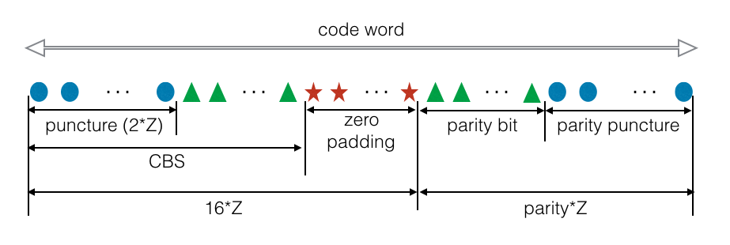

|  |  |
| --- | --- |
| K | Z(K) |
| 40~47 | 12 |
| 48~63 | 10 |
| 64~95 | 16 |
| 96~400 | 28 |
| 1000 | 64 |
| 2000 | 128 |
| 4000 | 256 |
| 6000 | 384 |
| 8000 | 512 |

CBS = 7808, Z = 512

|  |  |  |  |  |
| --- | --- | --- | --- | --- |
| CR | CBS | Zero padding | Parity bit | Parity puncture |
| 0.89 | 1024+6784 | 384 | 2000 | 48 |
| 0.83 | 1024+6784 | 384 | 2586 | 486 |
| 0.75 | 1024+6784 | 384 | 3626 | 470 |
| 0.67 | 1024+6784 | 384 | 4928 | 192 |
| 0.5 | 1024+6784 | 384 | 8832 | 384 |
| 0.4 | 1024+6784 | 384 | 12736 | 576 |
| 0.33 | 1024+6784 | 384 | 16640 | 768 |

CBS = 7168 Z = 512

|  |  |  |  |  |
| --- | --- | --- | --- | --- |
| CR | CBS | Zero padding | Parity bit | Parity puncture |
| 0.89 | 1024+6144 | 1024 | 1910 | 138 |
| 0.83 | 1024+6144 | 1024 | 2492 | 580 |
| 0.75 | 1024+6144 | 1024 | 3413 | 683 |
| 0.67 | 1024+6144 | 1024 | 4555 | 565 |
| 0.5 | 1024+6144 | 1024 | 8192 | 1024 |
| 0.4 | 1024+6144 | 1024 | 11776 | 1536 |
| 0.33 | 1024+6144 | 1024 | 15577 | 1831 |

CBS = 4160 Z = 384

|  |  |  |  |  |
| --- | --- | --- | --- | --- |
| CR | CBS | Zero padding | Parity bit | Parity puncture |
| 0.89 | 768+3648 | 1984 | 1282 | 254 |
| 0.83 | 768+3648 | 1984 | 1620 | 684 |
| 0.75 | 768+3648 | 1984 | 2155 | 917 |
| 0.67 | 768+3648 | 1984 | 2817 | 1023 |
| 0.5 | 768+3648 | 1984 | 4928 | 1984 |
| 0.4 | 768+3648 | 1984 | 7008 | 2976 |
| 0.33 | 768+3648 | 1984 | 9214 | 3842 |

CBS = 2624 Z = 256

|  |  |  |  |  |
| --- | --- | --- | --- | --- |
| CR | CBS | Zero padding | Parity bit | Parity puncture |
| 0.89 | 512+2624 | 1472 | 836 | 188 |
| 0.83 | 512+2624 | 1472 | 1049 | 487 |
| 0.75 | 512+2624 | 1472 | 1387 | 661 |
| 0.67 | 512+2624 | 1472 | 1804 | 756 |
| 0.5 | 512+2624 | 1472 | 3136 | 1472 |
| 0.4 | 512+2624 | 1472 | 4448 | 2208 |
| 0.33 | 512+2624 | 1472 | 5840 | 2864 |

CBS = 1088 Z = 128

|  |  |  |  |  |
| --- | --- | --- | --- | --- |
| CR | CBS | Zero padding | Parity bit | Parity puncture |
| 0.89 | 256+1600 | 960 | 390 | 122 |
| 0.83 | 256+1600 | 960 | 479 | 289 |
| 0.75 | 256+1600 | 960 | 619 | 405 |
| 0.67 | 256+1600 | 960 | 792 | 488 |
| 0.5 | 256+1600 | 960 | 1344 | 960 |
| 0.4 | 256+1600 | 960 | 1888 | 1440 |
| 0.33 | 256+1600 | 960 | 2465 | 1887 |

CBS = 528 Z = 64

|  |  |  |  |  |
| --- | --- | --- | --- | --- |
| CR | CBS | Zero padding | Parity bit | Parity puncture |
| 0.89 | 128+1296 | 496 | 193 | 63 |
| 0.83 | 128+1296 | 496 | 236 | 148 |
| 0.75 | 128+1296 | 496 | 304 | 208 |
| 0.67 | 128+1296 | 496 | 388 | 252 |
| 0.5 | 128+1296 | 496 | 656 | 496 |
| 0.4 | 128+1296 | 496 | 920 | 744 |
| 0.33 | 128+1296 | 496 | 1200 | 976 |